# PC Gamer T-GAMER Worthy AMD Ryzen 5 5600GT / 16GB (2x8GB) DDR4 / SSD 500GB

**R$2.564,21**

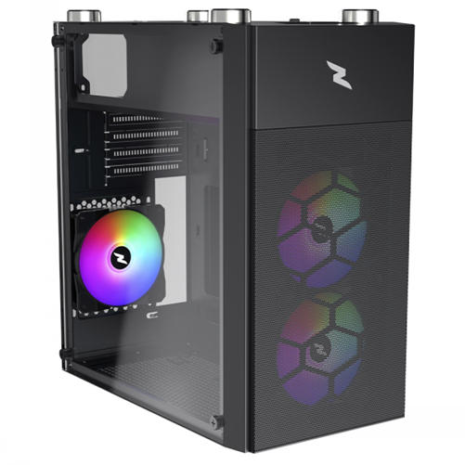

**Processador AMD Ryzen 5 5500 3.6GHz (4.2GHz Turbo), 6-Cores 12-Threads, Cooler Wraith Stealth, AM4, Sem Vídeo Integrado, 100-100000457BOX**

**R$649,90**

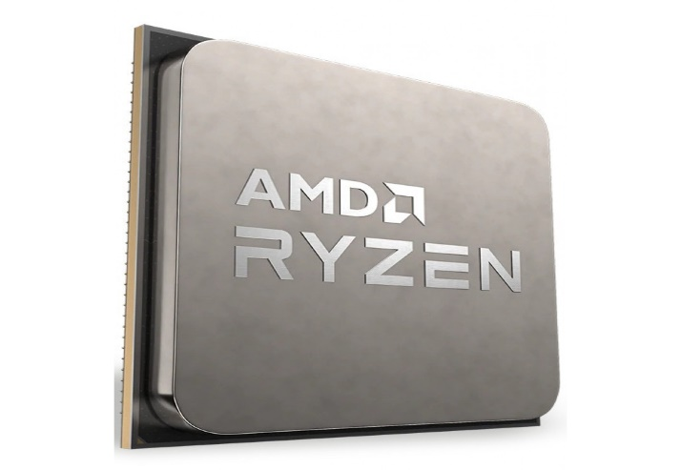

**Placa Mãe ASRock B450M Steel Legend, Chipset B45**

**R$769,90**

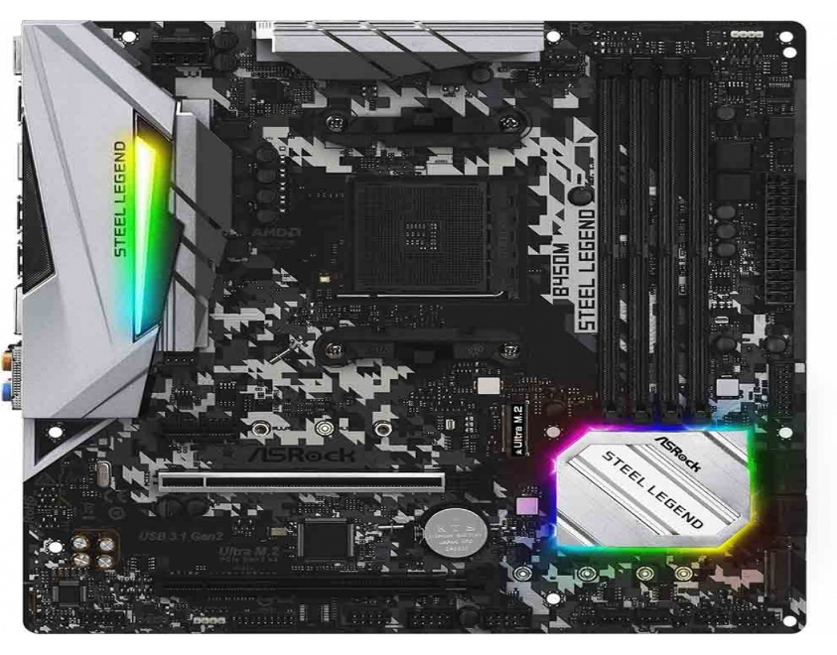

**Placa de Vídeo MSI RTX 3050 Ventus 2X XS OC NVIDIA GeForce, 8GB** **GDDR6 - 912-V809-4266**

**R$1.399,99**

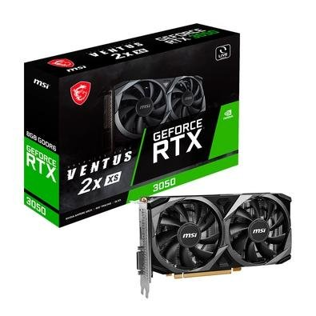

**HD SSD Kingston SA400S37 480GB**

**R$289,99**

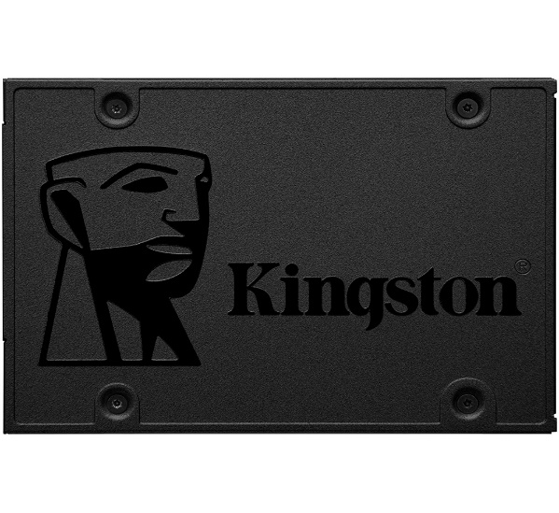

**Fonte XPG Core Reactor II 850G-BKCBR, 850W, 80 Plus Gold, Modular, PFC Ativo, Com Cabo, Preto - 75261198**

**R$ 699,99**

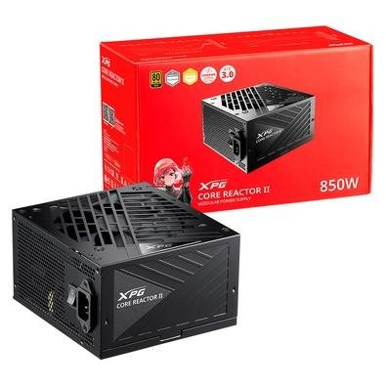

**Gabinete Gamer SuperFrame Wind, Mid Tower, Vidro Temperado, M-ATX, White, Sem Fonte, Com 3 Fans**

**R$229,00**

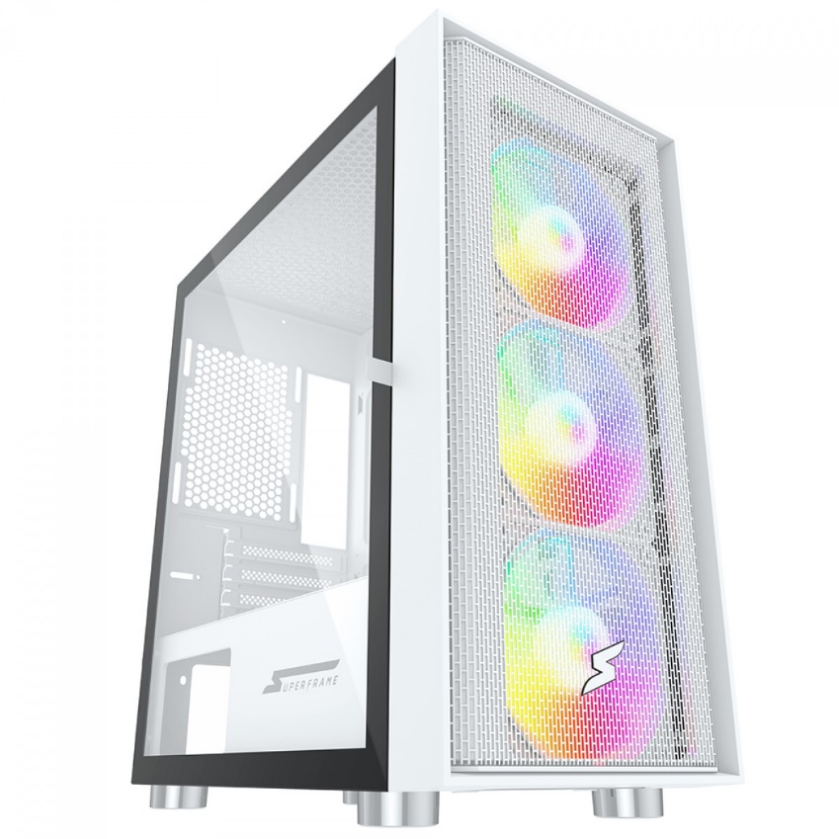

**Memória DDR4 Kingston Fury SuperFrame, RGB, 8GB**, **3200Mhz, Black, KF432C16BB2A/8DP1**

**R$219,90**

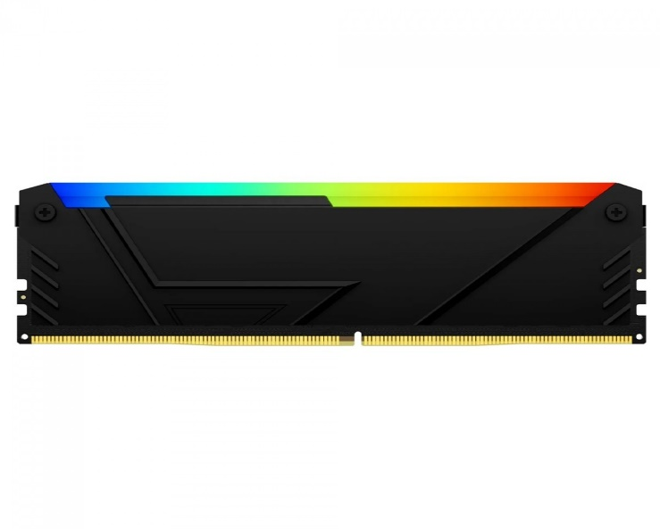

**Water Cooler SuperFrame ISENGARD, ARGB, 120mm, Intel-AMD, Controladora, Black, SF-W120**

**R$199,90**

